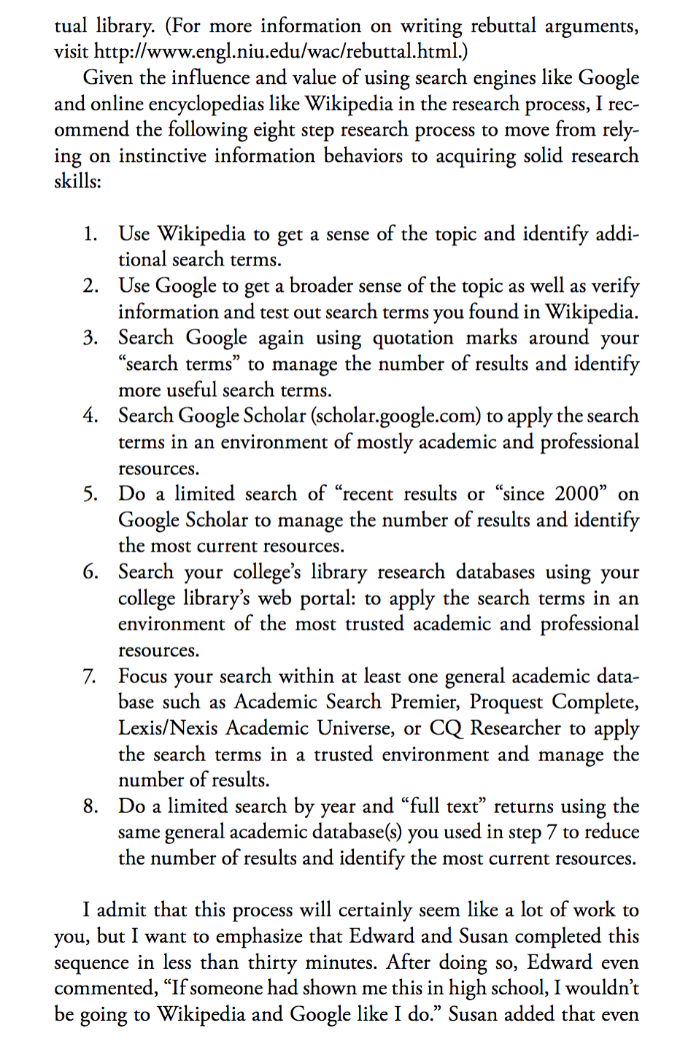

This can answer the point in assignment three about What Secondary research do you plan to use and find to help you in your research and why? Be specific with names of scholars or scholarly objects you have engaged with or plan to soon.

Also, you can access to my school library to apply the search terms in an environment of mostly academic and professional resources.

https://www.library.ucdavis.edu/

Thank you!

